Lab 2 Squirrel Text Game Game Design Doc

IWKS 3400

Project Description

*This game is a simple text adventure in the tradition of Colossal Cave. In this game, the player is directed to press a series of keys to make choices to navigate a simple game world. The example given here is a squirrel hunting for acorns. You are encouraged to change the story.*

*In future work, we’ll have Unity handle the levels of the game by creating new scenes, but in this case, we want to utilize a technique called a Finite State Machine (FSM), which works great for simple scenarios.*

1. Characters

*The player is The Squirrel. We have one static image to represent the player but otherwise no graphics. There is one crazy opponent Squirrel that our player has to avoid to win.*

2. Story *Very simply – the Squirrel wants to collect acorns and hide them in the hollow spot in the tree trunk. Different options will be present when on the ground and when up in tree that will amount to two “scenes.”*

3. Gameplay

3.1. Goal / Winning *– Collecting acorns*

3.2. User Skills *–key presses*

3.3. Game Mechanics – *text game loops (Finite State Machine)*

3.4. Losing *– If a player reaches too far in a narrow or dead branch, fighting the squirrel*

4. Technical description *– here let’s describe the states that will be possible in our game with a diagram.*

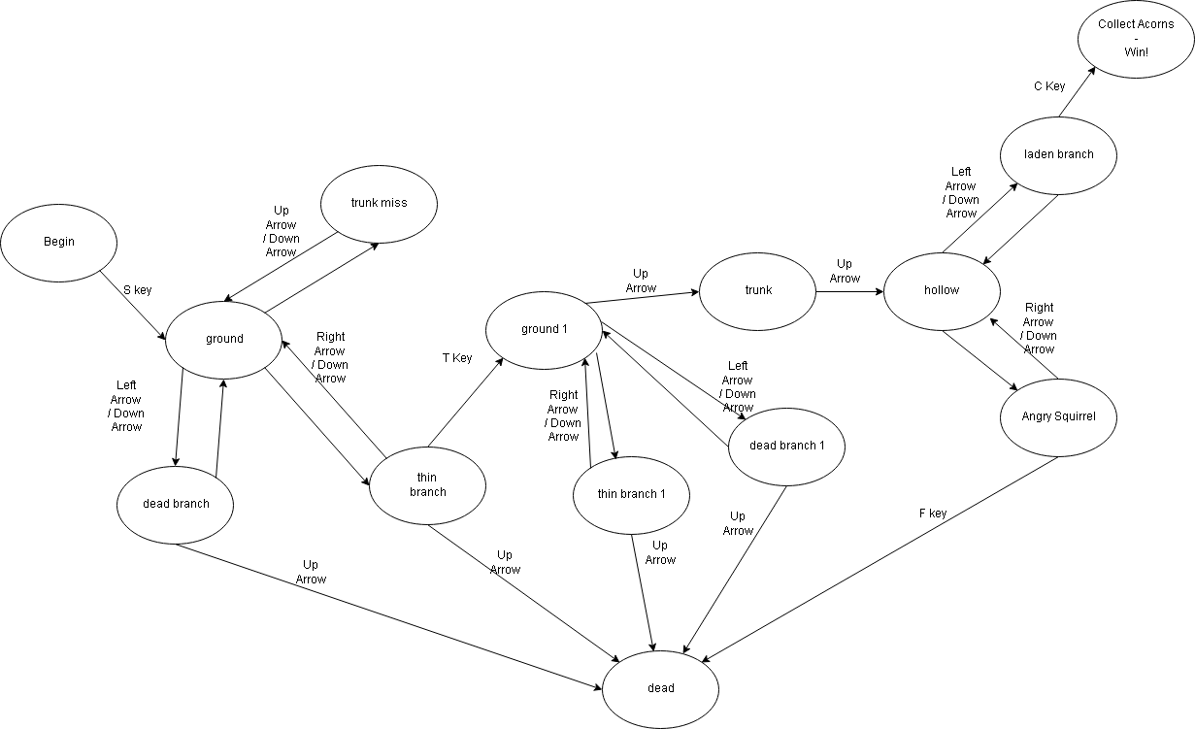

|  |  |  |
| --- | --- | --- |
| State | Condition | Next State |
| Begin | Press s | ground |
| Ground | Go up | Trunk miss |
| Ground | Go left | Dead branch |
| Ground | Go right | Thin branch |
| Dead Branch | Go down | ground |
| Dead Branch | Go up | Dead |
| Thin Branch | Go down | ground |
| Thin Branch | Go up | dead |
| Trunk miss | Go down | ground |
| Ground 1 | Go up | trunk |
| Ground 1 | Go left | Dead branch 1 |
| Ground 1 | Go right | Thin branch 1 |
| Dead Branch 1 | Go down | Ground 1 |
| Dead Branch 1 | Go up | dead |
| Thin branch 1 | Go down | Ground 1 |
| Thin Branch 1 | Go up | dead |
| trunk | Go up | hollow |
| hollow | Go left | Laden branch |
| hollow | Go right | Angry squirrel |
| Angry squirrel | down | hollow |
| Angry squirrel | Press f | dead |
| Laden branch | down | hollow |
| Laden branch | Press C | win |
| Win | Congrats message |  |

5. Art style *–N/A other than your own literary flair, so this might be the place to write out the text for the game, plan what twists and turns might happen.*

*For example, I’m going to start with: You are a hungry squirrel. You’re sitting at the foot of an oak tree. You can see it is laden with acorns, but you aren't sure which way to go.*